Edge Delivery Services: Document-Based Authoring Lab Session

Hands-On Experience with Lightning-Fast Publishing

# Overview

The Edge Delivery Document-Based Authoring Lab Session is designed to immerse participants in the practicalities of rapid content creation and publishing using Adobe Experience Manager's document-based approach, all within the high-performance framework of Edge Delivery Services. This hands-on lab empowers users of various technical backgrounds to experience how simplicity, speed, and scalability come together for modern web content management.

# Objective

* Demonstrate the end-to-end process of drafting, reviewing, and publishing content using familiar document tools, such as Microsoft Word or Google Docs.
* Leverage Edge Delivery Services to achieve near-instant publishing and superior site performance.
* Showcase streamlined collaboration, governance, and asset management throughout the content workflow.

# Lab Session Structure

* Introduction: Brief overview of Edge Delivery Services and the document-based authoring paradigm.
* Setup: Participants connect their preferred document editing tool to AEM, ensuring permissions and access are correctly configured.
* Drafting Content: Attendees create or edit sample web pages using Microsoft Word or Google Docs, focusing on clear structure, use of headings, and embedding multimedia assets.
* Collaboration: Demonstration of real-time co-authoring and commenting within the document, enabling seamless team input and feedback.
* Review & Approval: Walkthrough of the approval workflow—submitting drafts, assigning reviewers, and capturing feedback directly in the document interface.
* Publishing: Hands-on publishing via Edge Delivery Services, observing how changes appear live within seconds and how site speed and delivery are maintained through the cloud infrastructure.
* Analytics & Governance: Exploration of asset management, versioning, duplicate asset detection, and performance analytics using AEM’s integrated tools.
* Q&A: Open forum for addressing questions, sharing best practices, and troubleshooting common issues.

# Key Benefits Highlighted

* No Technical Barriers: Content creators use familiar document editors, reducing onboarding and training time.
* Speed to Publish: Updates move from draft to live in seconds, keeping sites fresh and relevant.
* Collaboration Made Easy: In-document commenting and review features streamline teamwork.
* Performance Optimisation: Edge Delivery ensures rapid load times and global scalability.
* Governance and Quality: Built-in analytics, duplicate detection, and approval workflows secure content quality and consistency.

# Participant Takeaways

* First-hand experience with the entire content lifecycle—draft, review, approve, and publish—without leaving the document editor.
* Understanding how Edge Delivery Services and document-based authoring combine to drive digital experience innovation.
* Practical knowledge of AEM’s tools for asset management, workflow automation, and content governance.

# Conclusion

This lab session underscores the power of marrying user-friendly document editing with Adobe’s state-of-the-art Edge Delivery Services. Participants leave confident in their ability to collaborate efficiently and publish at the speed digital audiences demand.

# Agenda

* Setup Edge Delivery project
* Publish / Preview content – Sidekick
* Utilizing Google Docs for authoring content.
* Distinguishing between content creation and coding/configuration tasks for the edge delivery services platform.

# Prerequisite

* Github account
* Google account
* Understand basics of HTML, CSS & JavaScript
* Node/npm installed for local development (only for Devs)

# Steps to setup Edge Delivery Services project|

* Create new repo using use this template option   
   Repo - <https://github.com/adobe/aem-boilerplate>

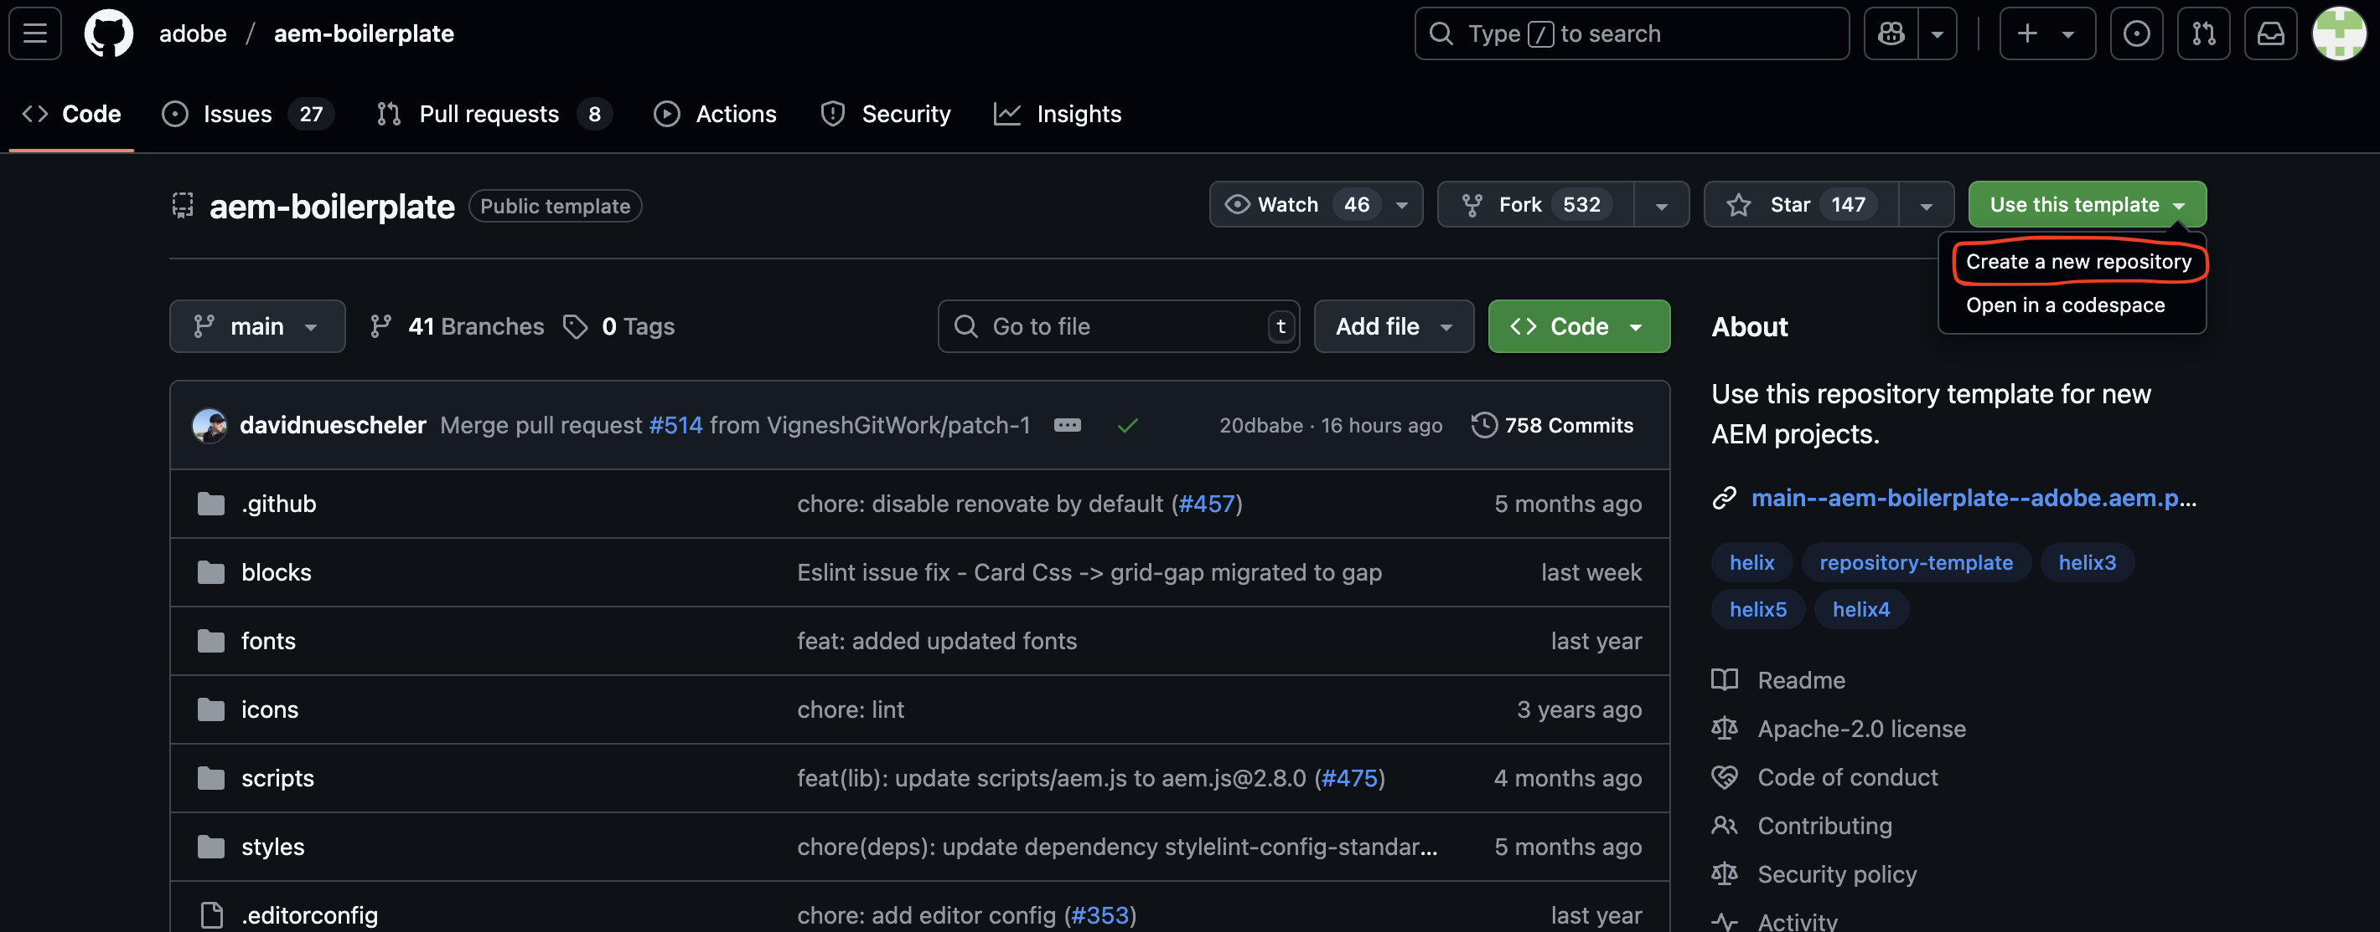

* Click the Use this template button and select Create a new repository, and select the user org that owns the repository  
    
  A screenshot of a computer

  AI-generated content may be incorrect.

Install the [AEM Code Sync GitHub App](https://github.com/apps/aem-code-sync) on your repository by visiting this link: <https://github.com/apps/aem-code-sync/installations/new>  
  
* Copy the started content to your Google Drive
* Share docs with [helix@adobe.com](mailto:helix@adobe.com)
* Use your own Google Drive. Update Google Drive path in fstab.yaml configuration file  
    
  A screenshot of a computer

  AI-generated content may be incorrect.

# AEM Sidekick to preview or Publish

* Install the Sidekick Chrome extension using <https://chromewebstore.google.com/detail/aem-sidekick/igkmdomcgoebiipaifhmpfjhbjccggml>

* Pin the extension to make it easier to find it.

* To set up the Chrome extension, go to your previously shared Google Drive folder and click the extension icon in the browser toolbar and select Add this project  
    
  A screenshot of a computer

  AI-generated content may be incorrect.
* you are now ready to preview and publish your content from your Google Drive.
* Open the index doc file and make some changes. Activate the Sidekick by clicking on your pinned extension and you can preview or publish the content.

For Devs : To get started with development.

npm install -g @adobe/aem-cli

git clone [https://github.com/<owner>/<repo](https://github.com/%3cowner%3e/%3crepo)>

From there change into your project folder and start your local development environment using the following.  
  
cd <repo>

aem up

This opens http://localhost:3000/ and you are ready to make changes.

Test your changes locally and then follow the standard process to push the code.

# 